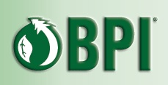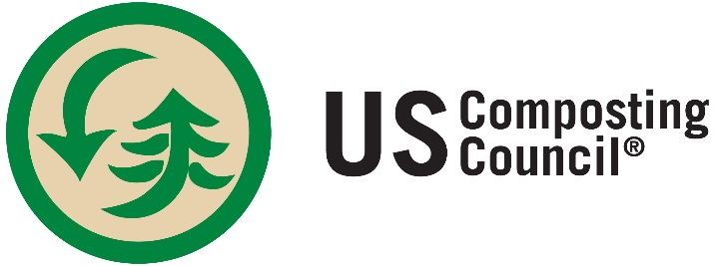

PRESS RELEASE DRAFT CONTACT: Rod Tyler, President, USCC
5/3/2015 rodt@filtrexx.com Steve Mojo, Director, BPI
execdirector@bpiworld.com

BPI and US Composting Council Strengthen Collaboration to Promote Growth of Food Scraps Diversion and Composting

Bethesda, MD – Healthy soil and global food security are intertwined, as are composting and diversion of food residuals. The US Composting Council and Biodegradable Products Institute (BPI) are solidifying their partnership to facilitate increased food scrap collection, diverting valuable materials from the waste stream for high quality compost manufacturing.

BPI will become a benefactor member of the USCC, the two groups announced today. This is the highest level of membership support for USCC, and builds on the recently signed Memorandum of Understanding (MOU) between the two organizations.

“USCC and BPI have been partners for more than a decade, and the Benefactor membership and MOU formalize that commitment,” said Steve Mojo, BPI executive director. “The compostable products industry and composting have a symbiotic relationship as certified compostable materials need composting to close the loop at the end of their life, but they also help to increase the tonnage of food scraps that are diverted from landfills to composting.”

BPI and its members have been major supporters of the USCC’s Compostable Plastic Task Force, an industry project to encourage compost manufacturers to work with product designers and developers so that end-of-life impact in composting is considered as decisions are made about compostable plastics. BPI’s benefactor membership solidifies its continuing support for the Task Force by creating an annual budget for the working group. In the MOU signed between USCC and BPI, the organizations set out these major goals for the coming years:
- Promoting the appropriate use of certified compostable products for collection and recovery of food scraps, yard trimmings, and other organic waste streams.
- Developing and providing resources and information in order to educate all stakeholders, both public and private, about the role and performance of certified compostable materials, and the importance of scientifically based standards;
- Promoting the use of professionally produced, high-quality compost;
- Promoting the development of municipal source separated organics (SSO) collection programs and processing infrastructure

“This is a more formal representation of more than 10 years of support by BPI,” said Rod Tyler, president of USCC. A key element of the partnership is for BPI to encourage its members to join the USCC by continuing to offer a significant discount on BPI fees, and for USCC to work with BPI members through the Task Force to ensure that new products are compatible with composting facilities.

About BPI
The Biodegradable Products Institute (BPI) is a 503-(c) 6, not-for-profit organization that educates, advocates, and certifies compostable materials to be safe for large-scale composting. It then licenses companies to use BPI Compostable Logo on products and marketing materials, helping consumers and composters make informed choices. It is the largest certification organization for compostable products in North America.
All certified products meet ASTM D6400 or D6868, based on testing in a BPI-approved laboratory.

About USCC
The US Composting Council, a national organization dedicated to the development, expansion and promotion of the compost manufacturing industry, was established in 1990 to encourage, support and perform compost-related research. The USCC promotes best management practices, establishes standards, and educates professionals and the public about the benefits of composting and compost utilization. The USCC seeks to enhance compost product quality, train compost manufacturers and stimulate and develop compost markets. USCC members include compost manufacturers, marketers, equipment manufacturers, product suppliers, academic institutions, public agencies, nonprofit groups and consulting/engineering firms.

