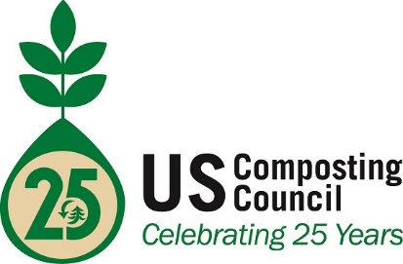
PRESS RELEASE
7/22/2016
CONTACT:
Frank Franciosi, Executive Director
ffranciosi@compostingcouncil.org
919-612-9975

200+ Compost Professionals Sign Up for First Certification Test Opportunity

To allow compost facility professionals to formally demonstrate their knowledge, professional achievement and qualifications, the USCC has taken the first steps this summer for compost facility operators to become a Certified Compost Operations Manager. More than 200 people have signed up for the initial round of tests within the first 30 days.

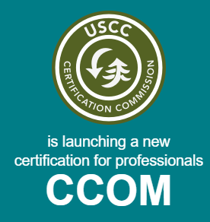
This summer’s launch of “beta tests”--- a trial version that will be formalized this fall when the final, fully developed program opens for registration—was offered in states where compost facilities are most numerous (see http://certificationsUSCC.org). The CCOM includes a process that requires the applicant to provide details of experience and training, as well as a successful grade on the test.

Those passing the beta test this summer will be able to apply and participate in the full program, which also includes requirements of experience and training, once it is opened for application in the fall.

“We are not surprised by the overwhelming interest in this; compost manufacturers have been looking for professional recognition for some time, and the USCC is glad to lead the process,” said Frank Franciosi, Executive Director. National certification will be a tool for states and local authorities to have a recognized and standard way of verifying qualifications for local compost manufacturers.

Compost facility operators who are interested in taking the summer test should visit http://certificationsUSCC.org, where the online registration form is located. Registrants receive followup information about locations for beta testing, which lasts until August 15 or until 150 people have completed the test.

About the US Composting Council
Established in 1990, the US Composting Council (USCC) is the only national organization in the United States dedicated to the development, expansion and promotion of the composting industry. The USCC achieves this mission by encouraging, supporting and performing compost related research, promoting best management practices, establishing standards, educating professionals and the public about the benefits of composting and compost utilization, enhancing compost product quality, and developing training materials for composters and markets for compost products. USCC members include compost producers, marketers, equipment manufacturers, product suppliers, academic institutions, public agencies, nonprofit groups and consulting/engineering firms.

The USCC is a non-profit 501(c) (6) organization that also directs the Composting Council Research and Education Foundation (CCREF), a 501(c) (3) charitable foundation, which administers public and private research and education activities.

