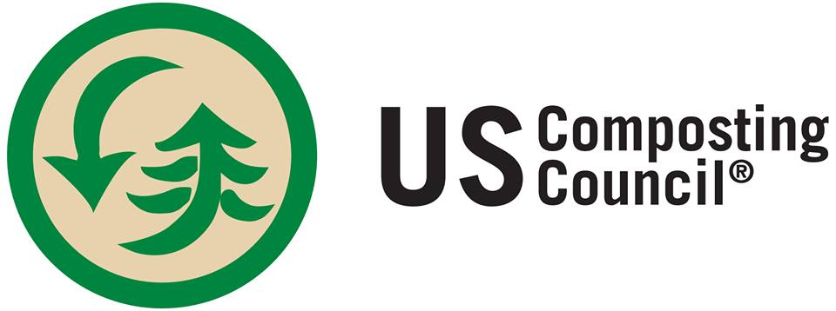

Michigan Organics Council Forms State Composting Council Chapter
Organics Council, Michigan Recycling Coalition Partner with USCC

Lansing, MI—(May 7, 2016)--Michigan composters have affiliated with the US Composting Council as a Charter Chapter to promote the compost manufacturing industry under the umbrella of the US Composting Council, the two groups announced today.
The Michigan Organics Council is now an official USCC chapter, sponsored by its parent organization, the Michigan Recycling Coalition.

“The partnership brings needed expertise to Michigan organics recyclers working hard to capture the nutrient value of waste organics for use by large and small Michigan markets,” said Kerrin O’Brien, executive director of the MRC.
The group currently has about 60 active members and works to promote the industry and educate state regulators, local officials and the public about the importance of the compost manufacturing industry to local waste management programs, jobs and business development and use of compost in commercial and residential landscaping, for stormwater management, erosion control and green infrastructure needs and its beneficial impact on carbon sequestration. The MOC and USCC will jointly take positions on regulations and legislation that affect the industry and the market for compost in the state.
“The USCC — and the compost industry — is most effective in places like Michigan where there is energy from an organized industry group,” said Frank Franciosi, executive director of the USCC. “Our chapters are important because their leadership is directly in touch with the members we work to serve.”
Michigan becomes the sixth regional chapter of the USCC. The industry is expanding due to increased efforts to removing food scraps from disposal along with traditional yard trimmings. The demand side of the industry is expanding with the growing recognition of the beneficial uses of compost.
California, Minnesota, Colorado, Virginia and North Carolina all have USCC chapters, and a Compost Council committee works on advocacy in the Maryland-DC Region.

For information about the Michigan chapter, contact Kerrin O’Brien, executive director, kobrien@michiganrecycles.org, or to start a chapter, contact Linda Norris-Waldt at lnorriswaldt@compostingcouncil.org.

